INSTITUTION: DEDAN KIMATHI UNIVERSITY OF TECHNOLOGY

COURSE: BSC. MECHATRONIC ENGINEERING

UNIT: MSP 2

UNIT CODE: EMT 3202

TITLE: LCD LAB EXERCISE AND KEYPAD LAB EXERCISE LAB REPORTS

LECTURER: MR GICHANE

DATE: 10TH January 2022

GROUP MEMBERS
- Geoffrey Theuri Kimani E022-01-0797/2019
- Elizabeth Musanga E022-01-0869/2016
- Newton Kariuki E022-01-0794/2019
- Kevin Kipkorir E022-01-0781/2019
- Joseph Kuria E022-01-0799/2019
- Mary Mbaire Mbugua E022-01-0745/2019

Arduino Mega LCD Lab Exercise

Introduction
Output devices are very essential in an embedded system. they are particularly used to output parameters. Some of the most used output devices are light emitting diodes (LEDs), Liquid crystal displays (LCDs) among others. LEDs are semiconductor devices used in electronic devices for indication purposes (Pham L.M, 2020). They are widely used as indicators during test for checking validity or results at different stages. They have advantage of being cheap as well as the fact that they can be designed in different sizes, shapes and colors. Additionally, they are also used in designing of message display boards and traffic control signals.
LCDs on the other hand are used to display graphical or text information in embedded systems. Examples of systems that use LCDs include, the card readers, ATM machines, digital measurement instruments, microwaves, digital clocks among others (Lee J.G, 2020).

Theory
Liquid Crystal Displays (LCD) Interfacing
LCDs (Liquid Crystal Displays) are used for displaying status or parameters in embedded systems. There are various configurations of LCD displays but a common one is the LCD 16x2. The LCD 16x2 has 2 lines with 16 characters in each line. Each character is made up of 5x8 (column x row) pixel matrix.
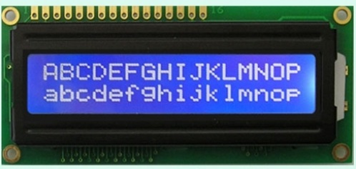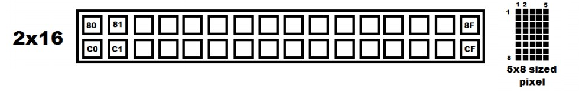
The positioning of the elements is as shown above. The LCD consists of 2 rows. The 1st starts from address 0x80 to 0x8F while the 2nd row starts from address 0xC0 to 0xCF. As shown each character is made from a row of 40 pixels arranged in a 5x8 matrix. The character usually utilizes 7 rows with the last row reserved for the cursor.
LCD 16x2 is a 16 pin devices which has 8 data pins (D0-D7) and 3 control pins (RS, RW, EN). The remaining 5 pins are for power supply and backlight for the LCD. The 3 control pins help us configure the LCD in command mode or data mode. They also help to configure the LCD into read mode or write mode. LCD 16x2 can be used in 4-bit mode or 8-bit mode depending on requirement of application. In order to use it we need to send certain commands to the LCD in command mode and once the LCD is configured according to our need, we can send the required data in read mode.
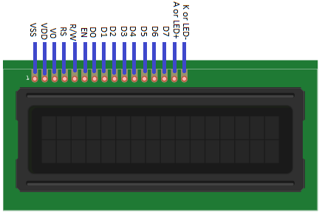
No. | PIN | Function
1 | VSS | Ground
2 | VCC | +5V
3 | VEE | Contrast control
4 | RS | Register Select
5 | RW | Read/Write pin
6 | EN | Enable pin (H-L pulse)
7-14 | D0-D7 | Data pins for data transfer
15 | LED+ | +5V
16 | LED- | Ground

Pin Description:
PIN 1 (VSS) and 2 (VCC) are used to supply power to the LCD i.e. ground and VCC.
Pin 3 - VEE pin; this pin is used for adjusting the contrast of the display. Voltage on this pin defines contrast on display, lower the voltage, higher the contrast. We can connect 4.7 k pot for contrast adjustment or simply connect this pin to ground to get maximum contrast.
Pin 4 –RS: Register Select pin:
RS = 0: Data on the D0 to D7 pins is considered as a command.
RS = 1: Data on the D0 to D7 pins is considered as data to display on LCD16x2.
Pin 5 – RW: Read / Write pin
RW = 0: Write data to the LCD
RW = 1: Read data from the LCD
Pin 6 –E: Enable; this pin is used to latch the data present on the data pins D0 to D7. High to low pulse with a minimum width of 450 ns is required to latch the data to the display.
Pins 7:14 - DATA pins D0 to D7; data pins are used to send data/command to the LCD16x2 as parallel 8 data bits.
Pin 15:16 - LED + and LED -; liquid Crystal Displays don’t have their own light like seven segment displays. Therefore, the module has a backlight LED. Supply to this LED is provided through these pins.
Interfacing LCD to Arduino
This is the process of displaying Text and Characters on LCD Screen using Arduino. A Liquid Crystal Display commonly abbreviated as LCD is basically a display unit built using Liquid Crystal technology. When we build real life/real world electronics based projects, we need a medium/device to display output values and messages. The most basic form of electronic display available is 7 Segment displays – which have its own limitations. The next best available option is Liquid Crystal Displays which comes in different size specifications.
Out of all available LCD modules in market, the most commonly used one is 16×2 LCD Module which can display 32 ASCII characters in 2 lines (16 characters in 1 line). Other commonly used LCD displays are 20×4 Character LCD, Nokia 5110 LCD module, 128×64 Graphical LCD Display and 2.4 inch TFT Touch screen LCD display.

LCD Advantages/Disadvantages

Advantages of LCDs:
· Consumes less power and generates less heat.
· Saves lot of space compared picture tubes due to LCD's flatness.
· Due to less weight and flatness LCDs are highly portable.
· No flicker and less screen glare in LCDs to reduce eyestrain.
Disadvantages:

The disadvantages of LCD displays are,
· LCDs cannot form multiple resolution images.
· The contrast ratio for LCD images is lesser than CRT and plasma displays.
· Due to their longer response time, LCDs show ghost images and mixing when images change rapidly.
· The narrow viewing angle of an LCD weakens the image quality in wider viewing angles.

Aims and objectives
- To interface a 16x2LCD with Arduino UNO
- To program an Arduino microcontroller from Atmel studio
- To write a code that will display a given information on an LCD and upload the code to the microcontroller.

Circuit Components
- Atmel studio
- Proteus
- Arduino Mega
- Jumper wires
- 16x2LCD
- Potentiometer (10 kilo-ohm)
- Resistor (10 kilo-ohm)

Arduino Mega LCD Lab Exercise Proteus Simulation Circuit
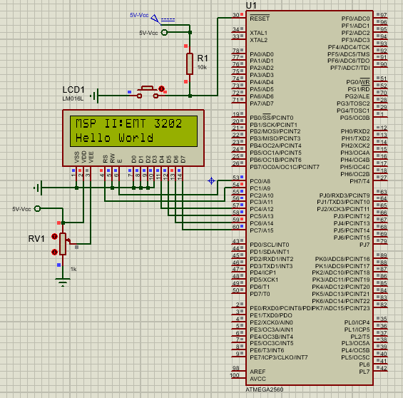

Procedure
We began the lab exercise by designing the LCD circuit in Proteus simulation software.
After the circuit designing, we wrote the specified code in Atmel studio. We then simulated the code in Proteus and the program worked perfectly. The simulation process was to counter any error that could arise when designing the project with our apparatus. After the simulation we connected the apparatus to the atmega 2560 microcontroller and followed the following procedure to upload the program into At mega 2560:
We began by downloading the latest version of Arduino Ide and opened it. We then connected our AT mega 2560 and configured the required settings in the IDE. In the File/preferences section, we selected the “Show verbose output during upload”. In the Tools/Board and Tools/Port sections, we ensured that the sections selected were right as per the microcontroller available. Then we Compiled and uploaded the blink example to ensure the atmega2560 was working. Once uploaded, In the IDE terminal we copied and pasted the command line from the 3rd line of the terminal output to a notepad. In the notepad we configured the command line as required by the Atmel studio and copied them into Atmel studio.
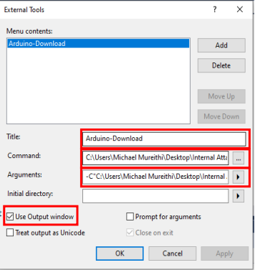
Finally, we built the LCD program which was uploaded into Atmega 2560. The code worked as required.

Arduino Mega LCD Lab Exercise Code
- Header File for LCD Functions
#ifndef LCD_HEADER_FILE_H_
#define LCD_HEADER_FILE_H_

/*Function Declarations*/
void LCD_Cmd(unsigned char cmd);
void LCD_Char(unsigned char char_data);
void LCD_Init(void);
void LCD_Clear(void);
void LCD_String(char *str);
void LCD_String_xy(char row, char pos, char *str);

#endif /* LCD_HEADER_FILE_H_ *

- C File for LCD Functions for 4-bit LCD operation Mode

#define F_CPU 16000000UL
#include <avr/io.h>
#include <util/delay.h>

#define LCD_Dir DDRC
#define LCD_Port PORTC
#define RS PC1
#define EN PC0

/*LCD command write function*/
void LCD_Cmd(unsigned char cmd){
/*Sending the first nibble of data (Higher 4 bits)*/
LCD_Port = (LCD_Port & 0x0F) | (cmd & 0xF0);/* Sending upper nibble */
LCD_Port &= ~ (1<<RS); /* RS=0, command reg. */
LCD_Port |= (1<<EN); /* Enable pulse ON */
_delay_us(1);
LCD_Port &= ~ (1<<EN); /* Enable pulse OFF */
_delay_us(200);
/*Sending the second nibble of data (Lower 4 bits)*/
LCD_Port = (LCD_Port & 0x0F) | (cmd << 4);/* Sending lower nibble */
LCD_Port |= (1<<EN); /* Enable pulse ON */
_delay_us(1);
LCD_Port &= ~ (1<<EN); /* Enable pulse OFF */
_delay_ms(2);
}
/*LCD data write function */
void LCD_Char (unsigned char char_data){
/*Sending the first nibble of data (Higher 4 bits)*/
LCD_Port = (LCD_Port & 0x0F) | (char_data & 0xF0);/* Sending upper nibble */
LCD_Port |= (1<<RS); /* RS=1, data reg. */
LCD_Port |= (1<<EN); /* Enable pulse ON */
_delay_us(1);
LCD_Port &= ~ (1<<EN); /* Enable pulse OFF */
_delay_us(200);
/*Sending the second nibble of data (Lower 4 bits)*/
LCD_Port = (LCD_Port & 0x0F) | (char_data << 4); /* Sending lower nibble */
LCD_Port |= (1<<EN); /* Enable pulse ON */
_delay_us(1);
LCD_Port &= ~ (1<<EN); /* Enable pulse OFF */
_delay_ms(2);
}
/*LCD Initialize function */
void LCD_Init (void){
LCD_Dir = 0xFF; /* Make LCD command port direction as output pins*/
_delay_ms(20); /* LCD Power ON delay always > 15ms */
LCD_Cmd(0x02); /* Return display to its home position */
LCD_Cmd(0x28); /* 2 line 4bit mode */
LCD_Cmd(0x0C); /* Display ON Cursor OFF */
LCD_Cmd(0x06); /* Auto Increment cursor */
LCD_Cmd(0x01); /* Clear display */
}

/*Clear LCD Function*/
void LCD_Clear(void){
LCD_Cmd(0x01); /* clear display */
LCD_Cmd(0x02); /* Return display to its home position */
}
/*Send string to LCD function */
void LCD_String (char *str){
int i;
/* Send each char of string till the NULL */
for(i=0;str[i]!=0;i++){
LCD_Char(str[i]);
}
}

/*Send string to LCD with xy position */
void LCD_String_xy (char row, char pos, char *str){
if (row == 0 && pos<16){
LCD_Cmd((pos & 0x0F)|0x80);/* Command of first row and required
position<16 */
}
else if (row == 1 && pos<16){
LCD_Cmd((pos & 0x0F)|0xC0);/* Command of second row and required
position<16 */
}
LCD_String(str); /* Call LCD string function */
}
- Project’s Main Function
#define F_CPU 16000000UL
#include <avr/io.h>
#include <util/delay.h>
#include "LCD_Header_File.h"

/*Our main program*/

int main(void)
{
LCD_Init(); /* Initialize LCD */
LCD_String("MSP II:EMT 3202"); /* Write a string on 1st line of LCD*/
LCD_Cmd(0xC0); /* Go to 2nd line*/
LCD_String("Hello World"); /* Write string on 2nd line*/
}

Observations
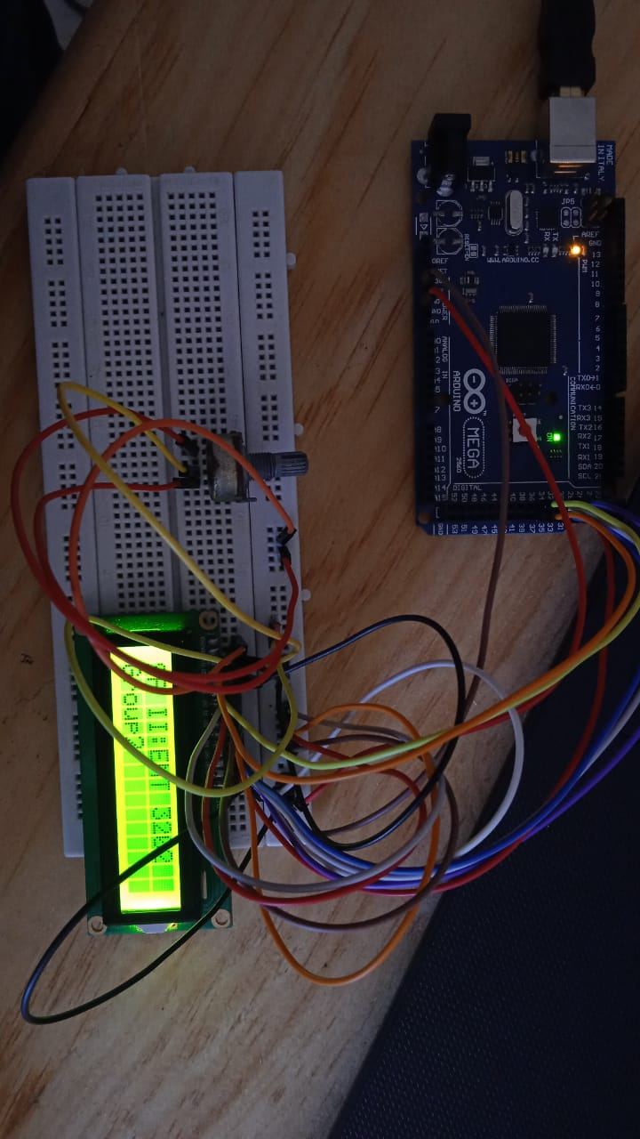

References
- Wei, G., Limin, Q., & Shanjun, Z. (2001). Interface and programming technic for liquid crystal display. Electrical Measurement & Instrumentation, 5.
https://en.cnki.com.cn/Article_en/CJFDTotal-DCYQ200105017.htm
- Jiao-chun, W. A. N. G., & Cheng-hua, W. A. N. G. (2008). Liquid Crystal Display System Design Base on DSP [J]. Advanced Display, 8.
https://en.cnki.com.cn/Article_en/CJFDTotal-XDYS200808009.htm
- Bahadur, B. (1984). Liquid crystal displays. Molecular crystals and liquid crystals, 109(1), 3-93.
https://www.tandfonline.com/doi/abs/10.1080/00268948408080827
4.Lab manual

B. Arduino Mega (atmega2560) Keypad Lab Exercise

Introduction
This report documents the structure and programming of a keypad interfaced with a liquid crystal display such that the digits pressed in the keypad are displayed on the display. Liquid crystal displays find vast application in calculators, petrol stations, mobile phones and computers.

Theory
A keypad is a block or pad of buttons set with an arrangement of digits, symbols, or alphabetical letters. Pads mostly containing numbers and used with computers are numeric keypads. Keypads are found on devices which require mainly numeric input such as calculators, television remotes, push-button telephones, vending machines, ATMs, Point of Sale devices, combination locks, and digital door locks. Many devices follow the E.161 standard for their arrangement.
Most of the applications of embedded systems require keypads to take the user inputs, especially in the case where an application requires more keys. With simple architecture and easy interfacing procedure, matrix keypads are replacing normal push buttons by offering more inputs to the user with the lesser I/O pins. As a Human Machine Interface (HMI) keypad plays a major role in vital microprocessor and microcontroller-based projects and equipment. Therefore, this article gives you a brief idea about the matrix keypad.
A Matrix keypad is the most used input device in many of the application areas like digital circuits, telephone communications, calculators, ATMs, and so on. A matrix keypad consists of a set of push-button or switches which are arranged in a matrix format of rows and columns. These keypads are available in configurations like 3×4 and 4×4 based on the application it is implemented for.
Keypad Internal structure

The 4*4 matrix keypad usually is used as input in a project. It has 16 keys in total, which means the same input values. At the lowest level, keyboards are organized in a matrix of rows and columns. The CPU accesses both rows and columns through ports. When a key is pressed, a row and a column make a contact. Otherwise, there is no connection between rows and columns. So, this is the logic we are going to use.
Key Scanning
The status of each key can be determined by a process called Scanning. There are many methods depending on how you connect your keypad with your controller, but the basic logic is the same. For the sake of explanation, let’s assume that all the column pins (Col1 – Col4) are connected to the input pins and all the row pins are connected to the output pins of the microcontroller. In the normal case, all the column pins are pulled up (HIGH state) by internal or external pull-up resistors. Now we can read the status of each switch through scanning.
1. A logic LOW is given to Row1 and others (Row2 – Row-4) HIGH
2. Now each Column is scanned. If any switch belongs to the 1st row is pressed the corresponding column will pull down (logic LOW) and we can detect the pressed key.
3. This process is repeated for all rows.
To program the keypad, encoders are used.

A keyboard encoder (also called keyboard controller) is a device that acts as the link between a keyboard and a computerized device. Their primary function is to inform the computer when an action takes place on the keyboard. When data from the keyboard arrives, the controller activates a keyboard interrupt notification to allow the central processing unit (CPU) to handle the input. If the keyboard encoder is not directly attached to the keys, the scan codes are received via a microcontroller embedded in the keyboard. Keypad encoders circuitry can be formed into a compact integrated circuit. An example of a keypad encoder IC is MM74C922, used in this project. The encoded makes programming much easier and reduces the number of keys used. This IC has a debouncing functionality and internal register that keeps data of the last key pressed, even after the key is depressed. The chip also has pull up devices that permit switches with up to 50 ohm resistance to be used.

Advantages and disadvantages of using a 4*4 keypad
Advantages
- It has an artistic appearance
- It is small, thin and light.
- It is Damp-proof, dustproof and oil resistant.
Disadvantages
- It is easy to make mistakes when typing using the keypad.
- Since the buttons are quite small it consumes a lot of time to enter data.

Aims and Objectives
To be able to get user input from key presses on the Keypad

Circuit Components:
- LCD Display module
- 10k, ohm potentiometer
- Arduino Mega
- Connecting wire
- Breadboard
- Computer for uploading the software

Arduino Mega Keypad and LCD Lab Exercise Proteus Simulation Circuit
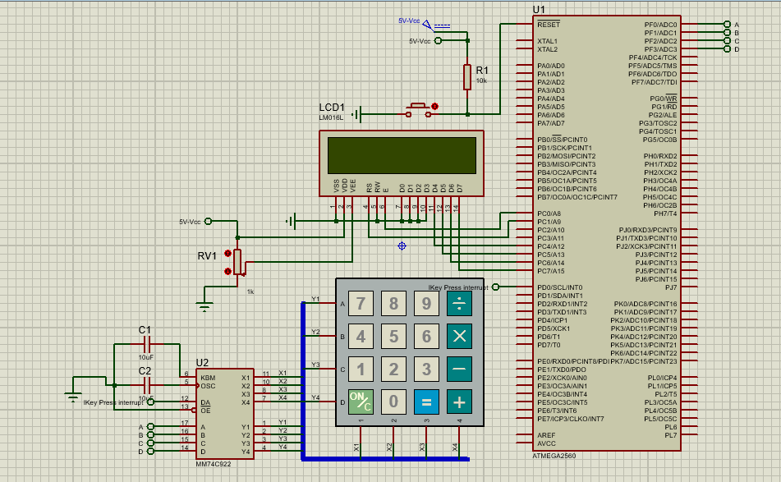

Procedure
1. Create the circuit above in Proteus Simulation software.
2. Using the code template below, write a control program to interface with the keypad using the key encoder and display the keys pressed on the LCD as stated above.
3. Using the components mentioned above, create the above circuit on a bread board and upload the code and observe the operation of the system.
4. NB: Call the supervisor to confirm your circuit before finalizing your connection and powering it.
5. Record your findings by recording the circuit diagram that you develop and its operations using pictures.

Arduino Mega Keypad and LCD Lab Exercise Code
The LCD Functions file and the header file for LCD functions in the LCD lab exercise section were the ones used in this exercise, thus the only code section that this exercise’s code from the one above is the main file.
This is the main file of this lab exercise
Main c File
define F_CPU 16000000UL

#include <avr/io.h>
#include <avr/interrupt.h>
#include <util/delay.h>

#include "LCD_Header_File.h"

#define KEYPAD_PIN PINF
// Function Declaration
unsigned char check_Keypad(char input_val);

// Variable Declaration
char value;
/* Keypad array holding the keys in a grid arrangement*/
unsigned char keypad[4][4] = {{'7','8','9','/'},
{'4','5','6','*'},
{'1','2','3','-'},
{'C','0','=','+'}};

ISR(INT0_vect){
value = check_Keypad(KEYPAD_PIN);
}

/* Function that checks the key that has been pressed on the keypad*/
unsigned char check_Keypad(char input_val){
int row = input_val/4;
int col = input_val%4;
if((input_val>= 0) & (input_val<16)) return (keypad[row][col]);
else return 0;
}

/* Setup function for the Keypad */
void keypad_Init(){
DDRD |= (0<<PD2); /* PORTD as input */

/* Interrupt setup */
MCUSR = 0;
EIMSK = EIMSK | (1<<INT0);
EICRA = EICRA | (1<<ISC01) | (1<<ISC01);

sei(); /* Enable Global Interrupt */
}

int main(void)
{
LCD_Init();
keypad_Init();
LCD_Cmd(0x80);
LCD_String("Key Pressed");
while (1)
{
LCD_Cmd(0xC0);
LCD_Char(value);
}
}

Observations
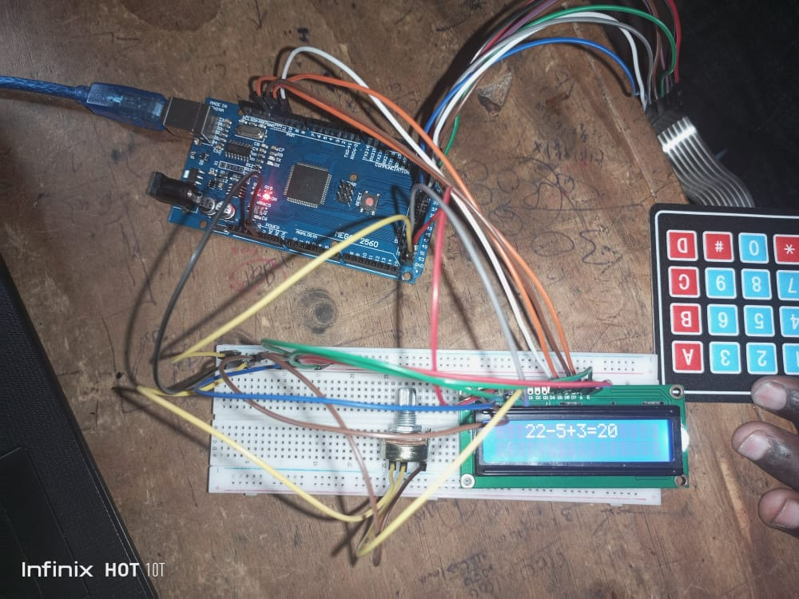

References
- Lesso, J. P., & Hardy, E. P. C. (2016). U.S. Patent No. 9,425,813. Washington, DC: U.S. Patent and Trademark Office.
- Valentine, G. J. (2020). U.S. Patent No. 10,720,098. Washington, DC: U.S. Patent and Trademark Office.
- Dekut mechatronic system programming lab manual
- Embedded systems programming 1 by John T Welch ,2000
- Programming Industrial Automation System by Karl-Heinz, Michael Tiegelkamp, Germany, 2001

